EDRC Use Case 1, Test Case 1, Section 7.2.11 Starting Conditions
Revision of EDRC doc:

11 | Updated to reflect comments from David Price | K Willshaw  30 March 2015

Test case spec release 1.0

Template Name : ClassifiedDescriptionOfIndividual

Role Name | Role Type | Role Value
hasDescribed | dm:PossibleIndividual | EQUIPMENT Identifier
valDescriptor | dm:ExpressString | The Text string holding the information
hasDescriptionType | dm:ClassOfClassOfDescription | STARTING CONDITIONS DESCRIPTION

Note a new RDL item for STARTING CONDITIONS DESCRIPTION will need to be added.

Comment : valIdentifier role type is incorrect in this table, the template actually states (tpl:valIdentifier only xsd:string)

Comments – the template URI for use in the exchange file is :
http://data.posccaesar.org/tpl/ClassifiedDescriptionOfIndividual

Comments – New test case RD URI for STARTING CONDITIONS DESCRIPTION used in test case is :
http://rdl.rdlfacade.org/data#STARTING_CONDITIONS_DESCRIPTION

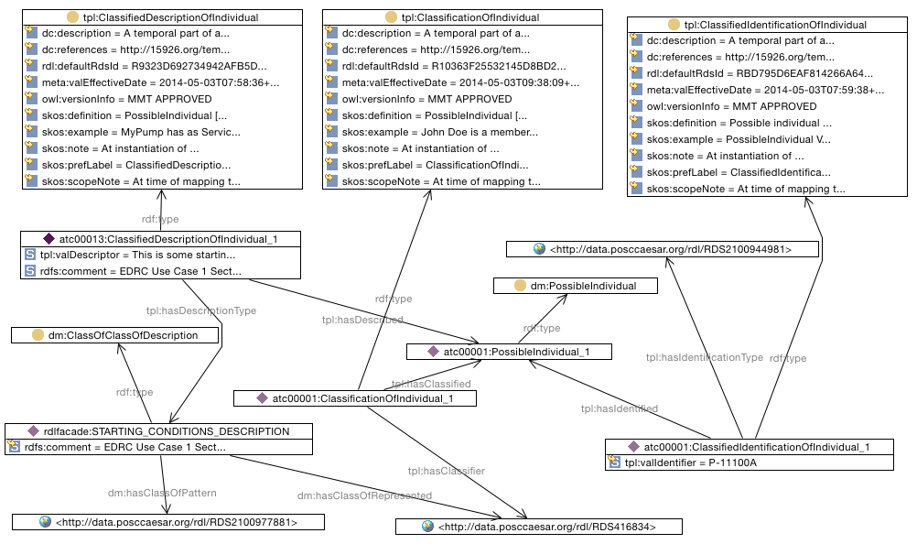

SPARQL to find Starting Conditions Description of Pump

SELECT ?PumpIdentifier ?PumpStartingConditionsDescriptionText
WHERE {
?classificationofindividual tpl:hasClassifier <http://data.posccaesar.org/rdl/RDS416834> .
?classificationofindividual tpl:hasClassified ?possibleindividual .
?classificationofindividual rdf:type tpl:ClassificationOfIndividual .
rdlfacade:STARTING_CONDITIONS_DESCRIPTION rdf:type dm:ClassOfClassOfDescription .
rdlfacade:STARTING_CONDITIONS_DESCRIPTION dm:hasClassOfPattern <http://data.posccaesar.org/rdl/RDS2100977881> .
rdlfacade:STARTING_CONDITIONS_DESCRIPTION dm:hasClassOfRepresented <http://data.posccaesar.org/rdl/RDS416834> .
?classifiedidentificationofindividual tpl:hasIdentified ?possibleindividual .
?classifiedidentificationofindividual rdf:type tpl:ClassifiedIdentificationOfIndividual .
?classifiedidentificationofindividual tpl:hasIdentificationType <http://data.posccaesar.org/rdl/RDS2100944981> .
?possibleindividual rdf:type dm:PossibleIndividual .
?classifieddescriptionofindividual tpl:hasDescribed ?possibleindividual .
?classifieddescriptionofindividual rdf:type tpl:ClassifiedDescriptionOfIndividual .
?classifieddescriptionofindividual tpl:hasDescriptionType rdlfacade:STARTING_CONDITIONS_DESCRIPTION .
?classifiedidentificationofindividual tpl:valIdentifier ?PumpIdentifier .
?classifieddescriptionofindividual tpl:valDescriptor ?PumpStartingConditionsDescriptionText .
}

Questions

For the new RD item, what are the correct class of pattern and class of represented. For now these have been set to be DESCRIPTION STRING CLASS and CENTRIFUGAL PUMP.

